**Exercise 1: Read Total profit of all months and show it using a line plot**

Total profit data provided for each month. Generated line plot must include the following properties: –

* X label name = Month Number
* Y label name = Total profit

The line plot graph should look like this.

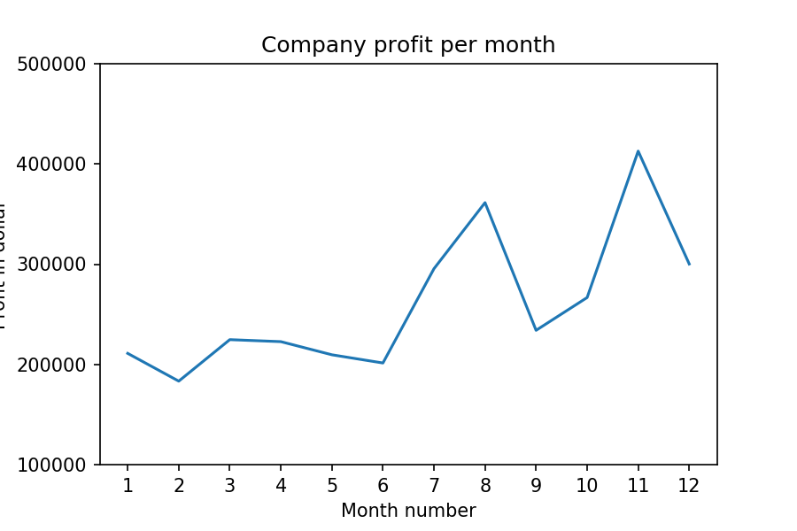

**Exercise Question 2: Get Total profit of all months and show line plot with the following Style properties**

Generated line plot must include following Style properties: –

* Line Style dotted and Line-color should be red
* Show legend at the lower right location.
* X label name = Month Number
* Y label name = Sold units number
* Add a circle marker.
* Line marker color as red
* Line width should be 3

The line plot graph should look like this.

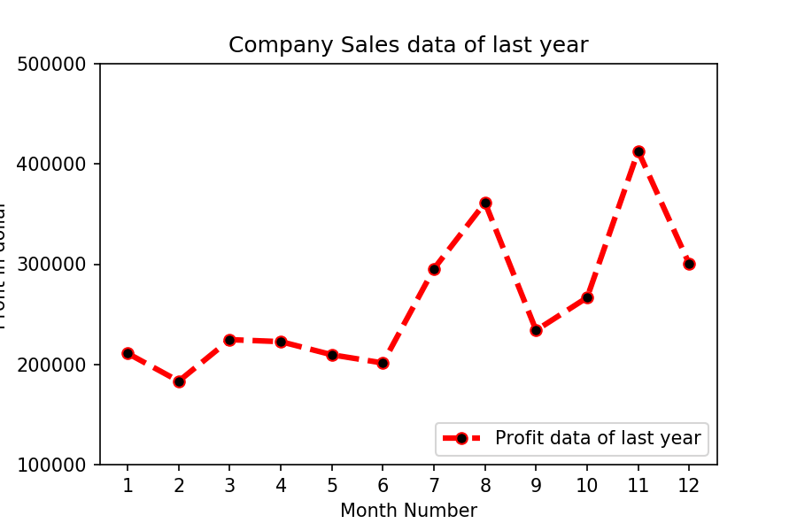

**Exercise Question 3: Read all product sales data and show it using a multiline plot**

Display the number of units sold per month for each product using multiline plots. (i.e., separate Plotline for each product).

The graph should look like this.

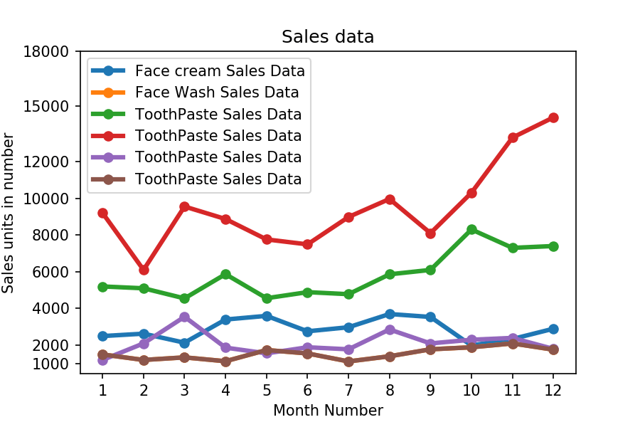

**Exercise Question 4: Read toothpaste sales data of each month and show it using a scatter plot**

Also, add a grid in the plot. Gridline style should “–“.

The scatter plot should look like this.

